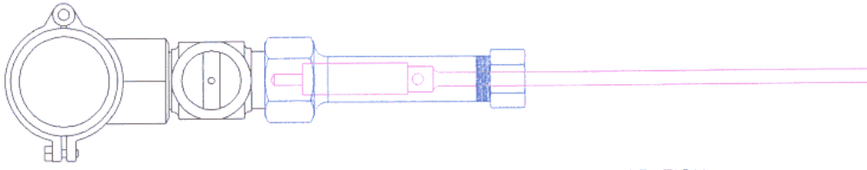
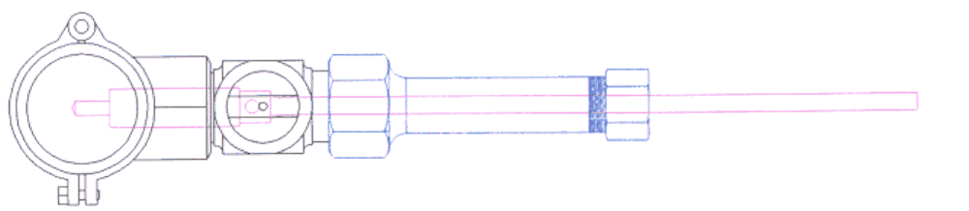
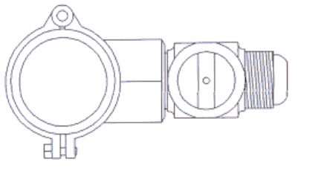
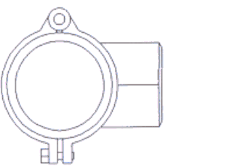

ATTACH SADDLE TO MAIN
1
“ALWAYS FOLLOW SADDLE MANUFACTURER’S INSTRUCTIONS”

ATTACH CORPORATION TO SADDLE
2
“ALWAYS FOLLOW CORPORATION MANUFACTURER’S INSTRUCTIONS”

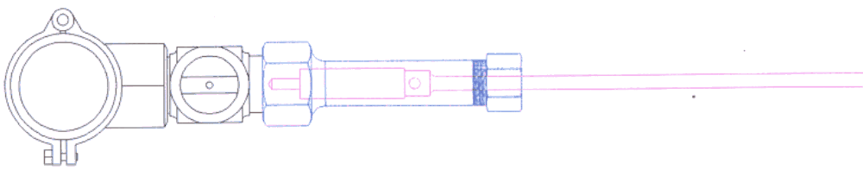

3

ATTACH TAP AND THEN ROTATE COCK ON CORPORATION TO OPEN POSITION
ENSURE YOU HAVE THE CORRECT FITTING TAP FOR THE CORPORATION YOU ARE USING, AND IT IS SECURELY FASTENED

4

SLOWLY DRILL THROUGH ONE WALL OF THE MAIN. SLUG IS TRAPPED BETWEEN SAW.
“ALWAYS FOLLOW PIPE MANUFACTURER’S INSTRUCTIONS”

5

RETRACT HOLE SAW AND CLOSE THE COCK ON THE CORPORATION

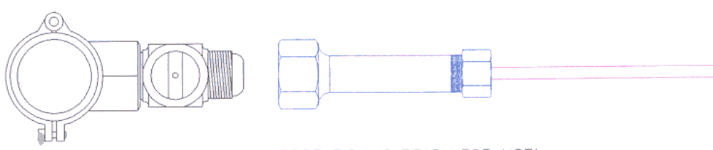

6

REMOVE TAP. CORPORATION IS READY FOR USE!

